<!DOCTYPE html>

<html>

<head>

<title>iasjdflkadsm</title>

<link rel="stylesheet" type="text/css" href="shadow.css">

</head>

<body>

<div id="container">

<div>

<h1>box-shadow</h1>

</div>

</div>

</body>

</html>

// \*\*\*\*\*\* CSS PART \*\*\*\*\*\*\* //

\*{

margin: 0;

padding: 0%;

}

#container{

background-color: black;

width: 100%;

height: 100vh;

position: relative;

justify-content: center;

display: flex;

}

#container div{

width: 300px;

height: 300px;

background-color: black;

top: 25%;

position: absolute;

/\* box-shadow: 30px 30px 20px rgb(0, 50, 0, 0.5); \*/

box-shadow: inset 0 0 1em green, 0 0 1em red;

box-sizing: border-box;

padding: 10px;

text-align: center;

border-radius: 1em;

}

h1{

color: rgb(223, 225, 223);

text-shadow: 0px 0px 1em rgb(252, 8, 231,1);

}

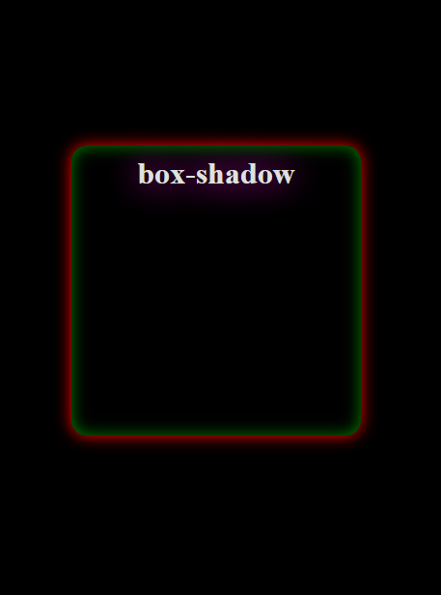

Using the same HTML...



\*{

margin: 0;

padding: 0%;

}

#container{

background-color: black;

width: 100%;

height: 100vh;

position: relative;

justify-content: center;

display: flex;

}

#container div{

width: 300px;

height: 300px;

background-color: black;

top: 25%;

position: absolute;

/\* box-shadow: 30px 30px 20px rgb(0, 50, 0, 0.5); \*/

/\* box-shadow: inset 0 0 1em green, 0 0 1em red; \*/

box-shadow: inset 5em 1em gold;

box-sizing: border-box;

padding: 20px 0px;

text-align: right;

border-radius: 1em;

}

h1{

color: rgb(223, 225, 223);

text-shadow: 0px 0px 1em rgb(252, 8, 231,1);

letter-spacing: 5px;

}